Math 1 Name ______________________________  
**3-3 Solving Systems by Elimination** Date________

* *I can solve systems of equations using elimination.*

|  |
| --- |
|  |

*Elimination Method Part 1*

Write the solution as an **ordered pair**.

Goal: Add or subtract the functions from each other to eliminate one of the variables so that you can solve for the other variable

1. 2.

3. 4.

5. 6.

*Elimination Method Part 2*

1. Graph the following system on the below coordinate plane (graph quickly by finding the *x*- and *y*-intercepts). Graph each line in a different color.

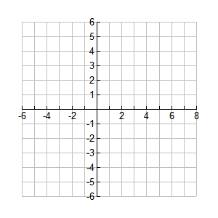

2. What is the solution to this system?

3. Take the top equation and multiply both sides of the equation by -2. Graph this new equation in a new color.

 🡪

4. What do you notice about the equation from number (3) and the original equation? Explain why this makes sense algebraically.

5. Add the two original equations from number (1) together. Graph the resulting equation in yet another color.

3*x* - 2*y* = 12

+ 2*x* - 4*y* = 16

____*x* + ___*y* = ____

6. What do you notice about the graph of your new equation from number (5) in relation to the graph of the system of equations from number (3)? *Think in terms of the solution to the original system.*

7. Below, rewrite the original system of equations from number (1), but replace the top equation with your equation from number (3). Thinking about your answer to number (4), explain why this replacement does not change the solution to the original system.



8. Add the two equations in your system from number (7) just as you did in number (5). What happens? Why would this be helpful if you were trying to solve the system algebraically?

9. Use your resulting equation in number (8) to solve the system algebraically (remember, you have to find both an *x* **and** *y* value).

10. Apply what you have learned in Numbers 1 – 9 to try to solve the following system:



Solve the following systems of equations using elimination.

11. 

12. 

13. 

14. 

15. 

16. 

17. 

18. 

19. 